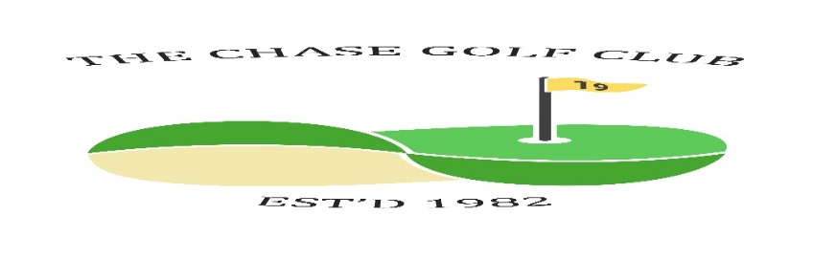
The Chase Golf Club

Competition Draw Sheet - Past Friends Salver
Dates: Wed Apr 24th Fri 26th Sat 29th Sun 30th Venue Girvan

Time &  initials | Wednesday Draw
11.20 | S Smith | J Burnett | G Cavanagh
11.10 | D Edgar | S Kelly
Time &  initials | Friday Draw
Time &  initials | Saturday Draw
09.30 | A Smeeton | R Greenwood | S Hannah
09.40 | A Muir | T Bloor | S Kirk
11.00 | R McCubbin | D Beattie | A McIntyre
Time &  initials | Sunday Draw
09.50 | E Borland | W Rae | H Mackie
11.00 | J Cathcart | I Gray | R Gilchrist
11.20 | J Brodie | I Speirs | J Taylor
Now the draw has been made you are not able to change days without express consent from a Committee member under the permitted playing conditions. Failure to contact a Committee member will lead to disqualification.
Format | 18 holes white | Handicaps | Strokeplay Max 28 | Prizes | More than 10 players 1/2/3  Less than 10 players 1/2  Less than 5 is winner only
N.B. If you withdraw from a game, then you must contact all players in your group to let them know. Failure to do so will result in players left without a game and the Committee will take action against offender(s).

